## Lab 2. Approvals (Part 1) - [Travel Approval](https://preview.flow.microsoft.com/en-us/galleries/public/templates/febbc8ca916946d3ac5280060c4ae1a7/submit-a-travel-request-for-approval/)

**Author:** Serge Luca aka “Doctor Flow”**.**

**Learning objectives:** Approvals and conditions.

**Duration:** 20 minutes.

**Scenario:** A user stores his/her travel information in a SharePoint list named Travels. When a new travel request is created, a flow is triggered and ask a manager to Approve/Reject.

**Prerequisites**: Each student must have a dedicated custom SharePoint list named Travels_<name>. The list must have 3 fields: Title, Amount (currency), Status (single line of text). The student will create this list in the first task of this lab.

**Remarks:** the first time an approval is created in a tenant, the system creates the infrastructure (Common Data Service) needed for the approvals. Therefore, the first approval may take some time to appear.

#### Task 2.1: Create a SharePoint list

1. Create your own custom SharePoint list using the following steps:
   1. Go to your SharePoint site. The site URL is:**<tenant URL>sites/Flowinaday.**
   2. Click **New** > **List**:

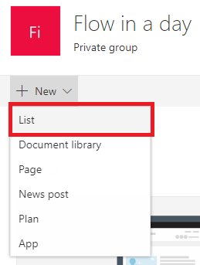

* 1. In the **Name** text box type something similar to, **Travels_<YourFirstnameYourLastname>.**Ensure the list name is unique.
  2. Click **Create**.

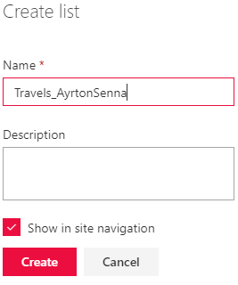

1. Add 2 columns, Amount, and Status using the following steps:
   1. Click **Add column** > **Currency**.

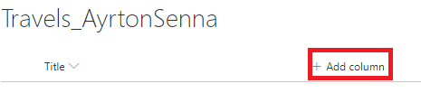

* 1. Provide the following information, and then click **Save**.

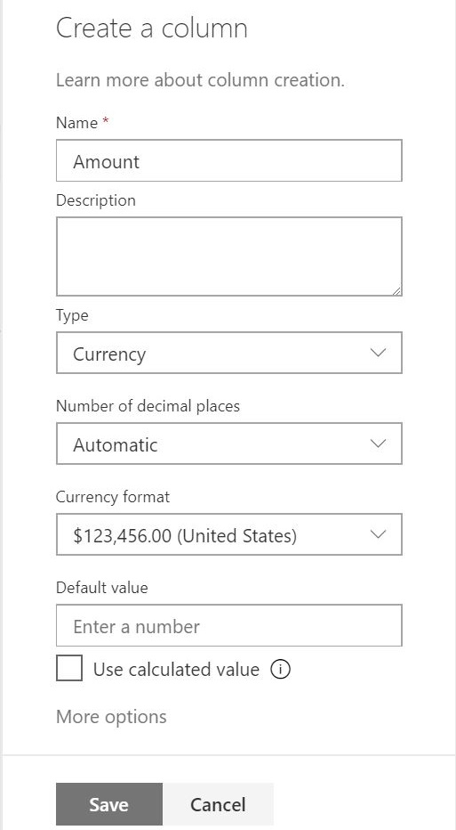

1. Add a **Single line of text** column named **Status**.

#### Task 2.2: Create an approval flow

1. Create a new Automated flow triggered when an item is created in a SharePoint list, using the following steps:
   1. **New** > **Automated – from blank**.

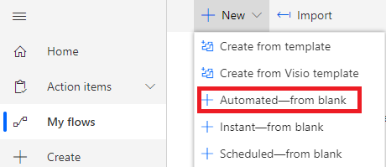

* 1. In the **Flow name** text box, type **Expense approval**, and select the SharePoint trigger **When an item is created.**

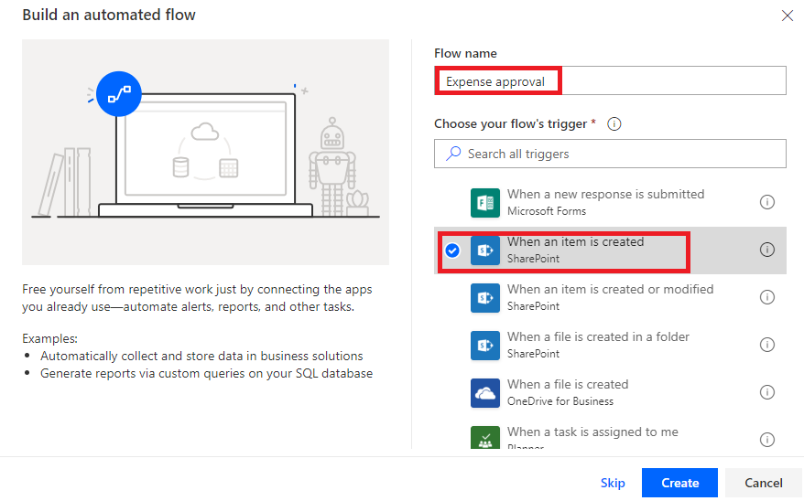

* 1. Click **Create**.

**Note:** If you have not connected to Office 365, SharePoint or Approvals before, you will need to provide your credentials to create connections to these services.

* 1. From the **Site Address** drop-down list, select your SharePoint site and then from the **List Name** drop-down list select your list.

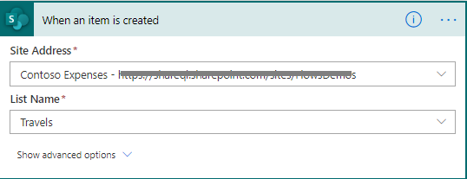

1. Add am approvals action
   1. **New step** > **Start and wait for an approval**.  
      Hint: search for approval.

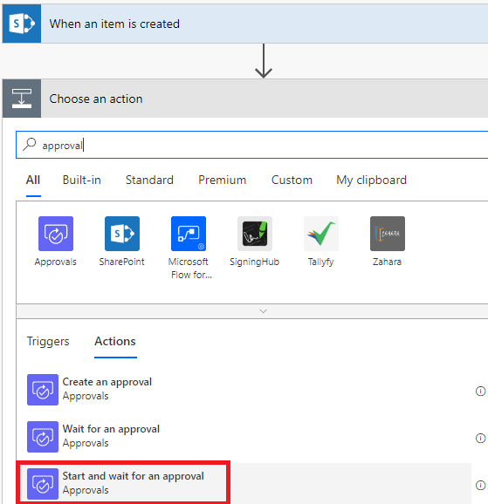

* 1. **Approval type** > **Approve/Reject -First to respond**
  2. **Title >** type **Please approve the following expense**
  3. **Assigned to** > type the e-mail address (the one provided by the trainer in the training tenant)
  4. **Details** > type the text as per the following screenshot:

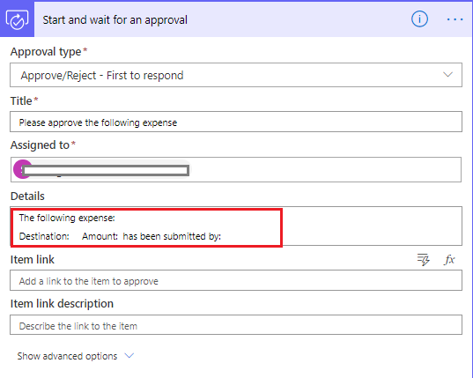

* 1. To define the destination, place the cursor to the right of destination; in the action panel, click the **Add a** **dynamic value** button.
  2. Scroll down to dialog and select **Title** from the trigger **When an item is created**:

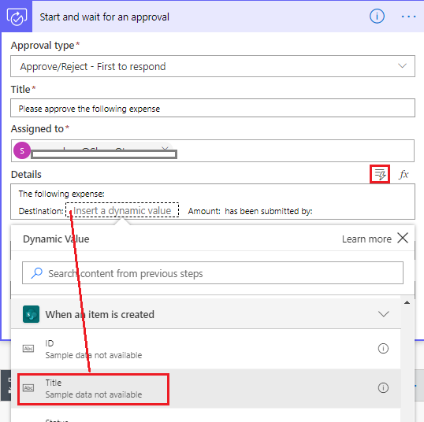

* 1. Repeat the step above to select **Amount** and for the submitter: **Created By Display Name** properties.

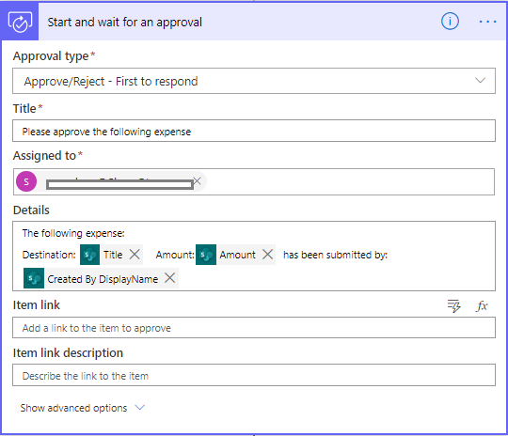

* 1. Use the Dynamic value button to set the **Item link** > **Link to item**

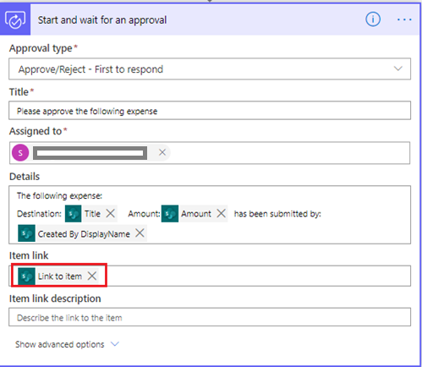

1. Add a condition action using the following steps:
   1. After the **Start and wait for approval** action, select **New step** > **Condition control**

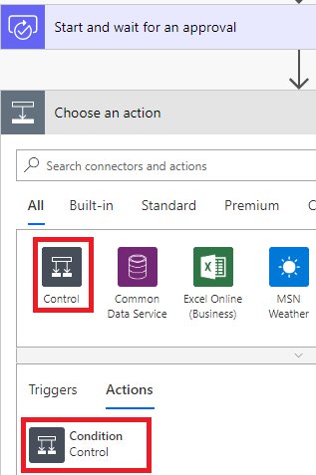

A condition is added to the flow containing three boxes, *choose a value*, *is equal to* and *Choose a value*.

* 1. In the left **Choose a value** text box, use the Dynamic content tab to select **Outcome** from the approval action:

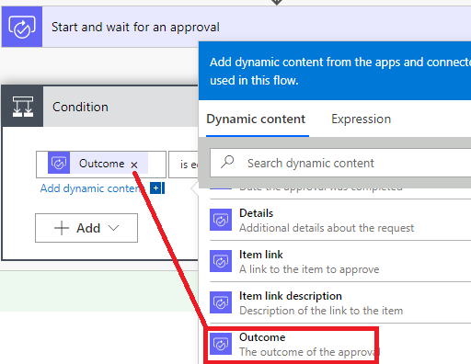

* 1. In the right **Choose a value** text box, type **Approve**:

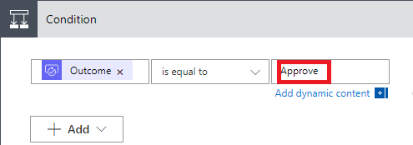

1. Add a SharePoint Update item action to the *If yes* branch of the condition using the following steps:
   1. In the **if yes** branch, click **Add an action**, and select the SharePoint **Update item** action:

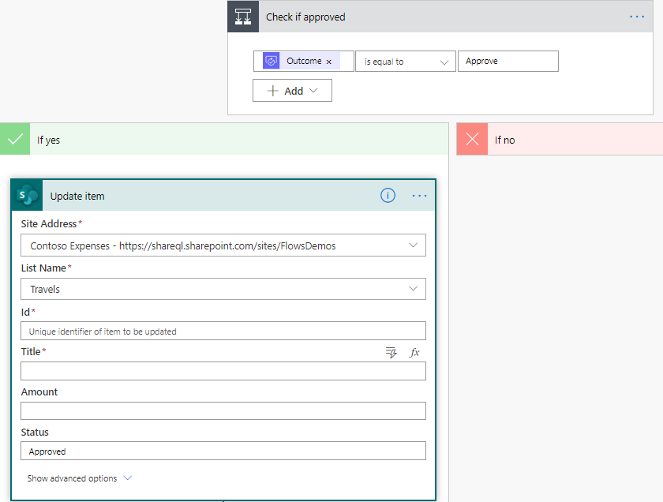

* 1. Use the **dynamic value** tab to set **Id** > **ID** from the trigger:

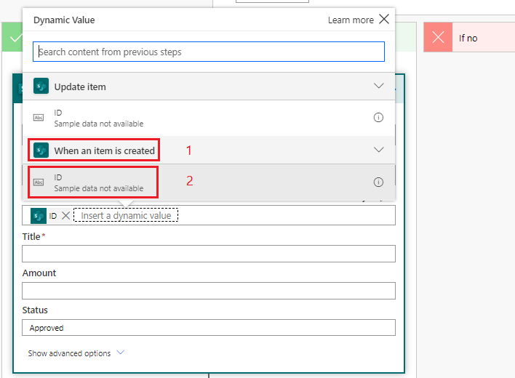

* 1. Use the **Dynamic value** button to set **Title** >**Title** from the trigger.
  2. **Status** > type **Approved:**

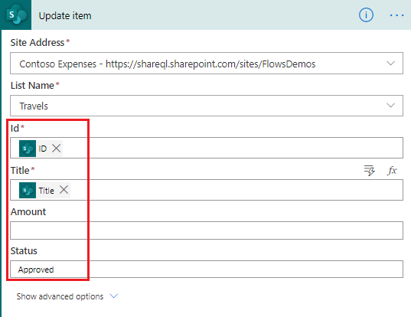

1. Complete the *If no* branch of the condition using as a starting point the SharePoint action from the If Yes branch.
   1. On the **Update item** heading, click the three dots and select **Copy to my clipboard**.

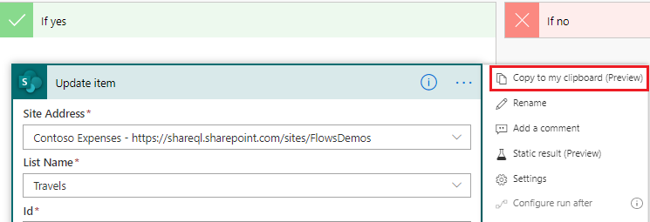

* 1. In the **If no** branch, click **Add an action**.
  2. Click the **My clipboard** tab, and select **Update item**.

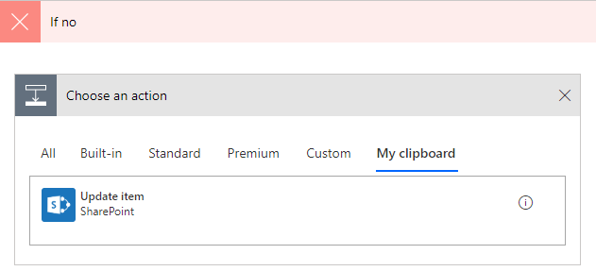

* 1. Change **Status** to **Rejected**:

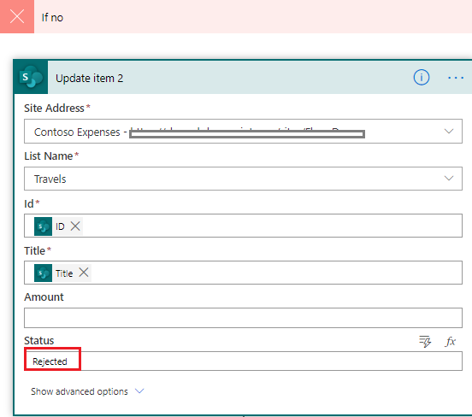

* 1. Rename the condition and the two update item actions as shown in the following screenshot:

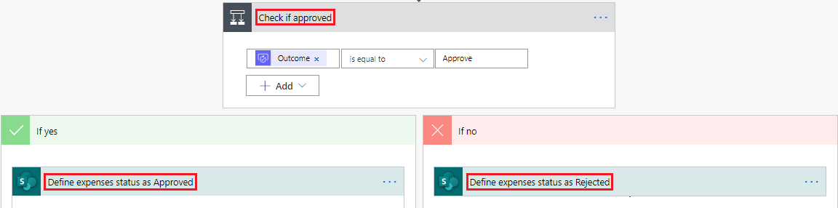

1. Send an email if the expense is approved or rejected, by using the following steps:
   1. In the **If Yes** branch, **Add an action** > **Send an email (V2)** action (Office 365 Outlook).
   2. Complete similar to the following screenshot:

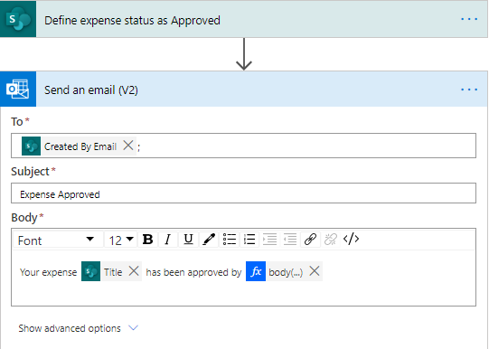

* 1. Place the cursor to the right of **approved by**; in dialog pane, click the **Add an expression** button,

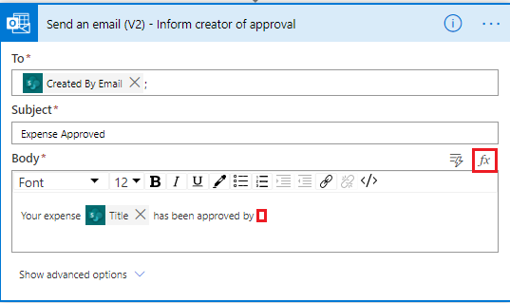

* 1. copy and paste the following expression in the Expression area and click “Add an expression”:

body('Start_and_wait_for_an_approval')?['responses'][0]['responder']['displayname']

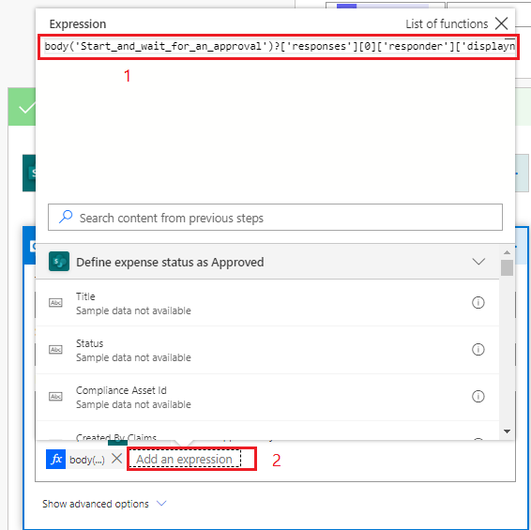

* 1. In the dialog pane, click **OK**.

Your Send an email action should look similar to the following screenshot.

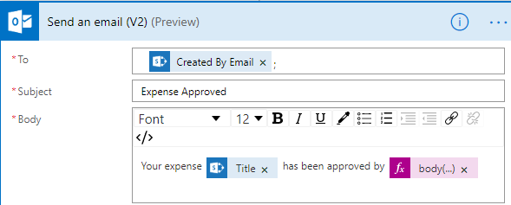

* 1. Similar to before, copy and paste the **Send an email** action to the **if no** branch and update the text with **rejected**.

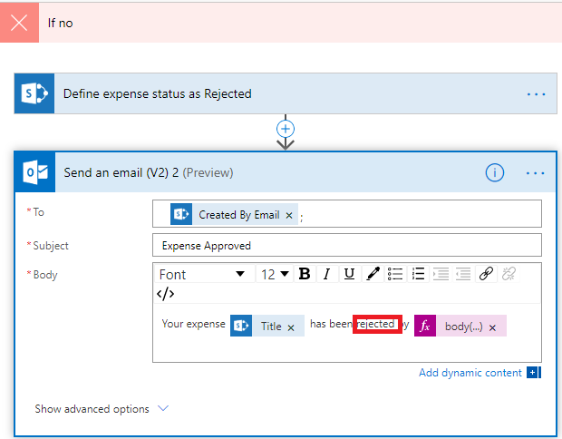

* 1. Rename the **Send an email** actions in both branches as **Inform creator of approval** and **Inform creator of rejection**.

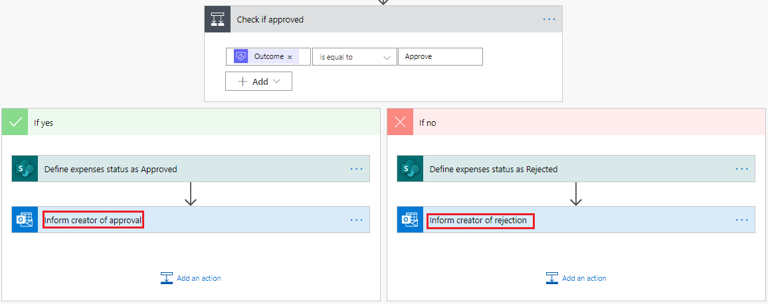

1. Save the flow.
2. Test the flow by adding an expense item to the SharePoint list, using the following steps:
   1. Navigate to your SharePoint list, for example by clicking on the list name on the Quick Launch bar.

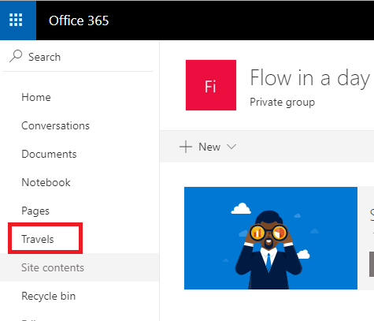

* 1. Click **New**:

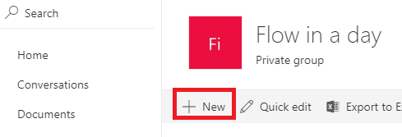

* 1. Complete the form similar to the following screenshot (keep the **Status** field empty):

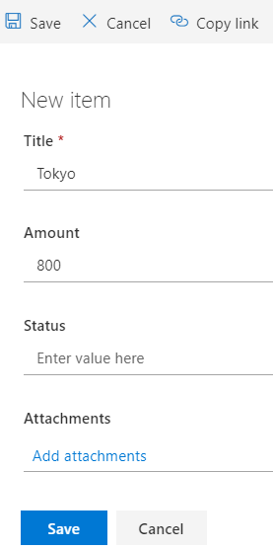

* 1. Save the new record, which will automatically trigger the flow.
  2. Check the flow status, it should be **running**:

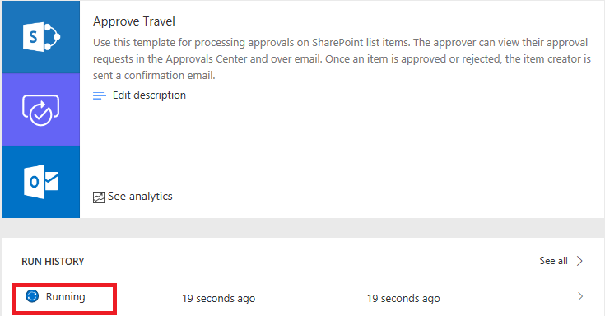

* 1. Click the running flow to see the progress of this instance of the flow:

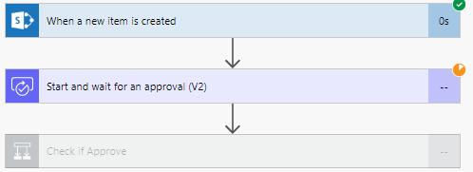

In this screenshot the flow is waiting for approval. Approvals send an e-mail to the person(s) in charge of the approval.

* 1. Check your e-mail to display your approval e-mail:
     1. To check your e-mails, click the app launcher (the waffle).

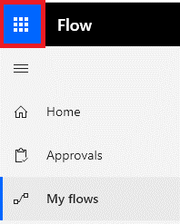

* + 1. In the list of Apps, right-click **Outlook**, and select **Open in new tab**.
    2. In the Focused tab or in the Other tab you should see your Flow approval e-mail:

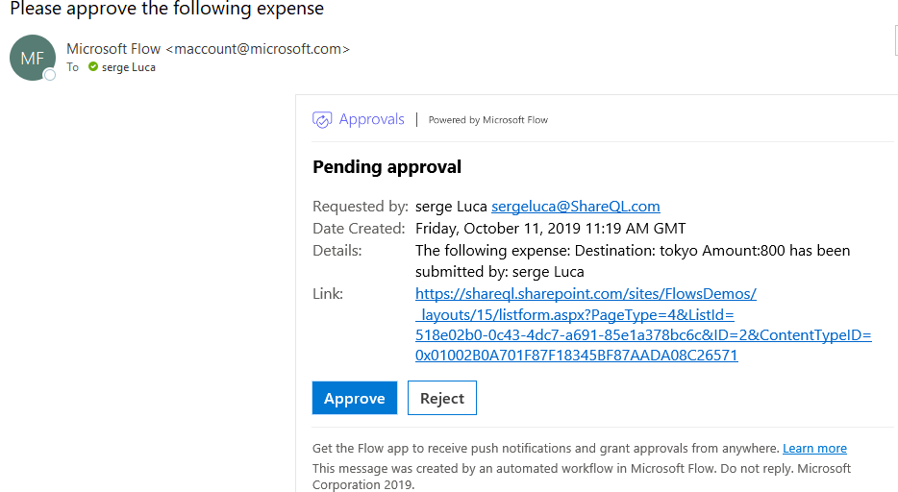

* 1. Approvers can also find the pending approvals in the **Approvals center**:
     1. Expand **Action items**, and then click **Approvals**.

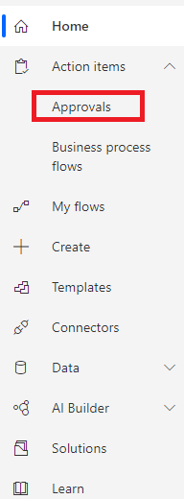

The Approvals center is displayed.

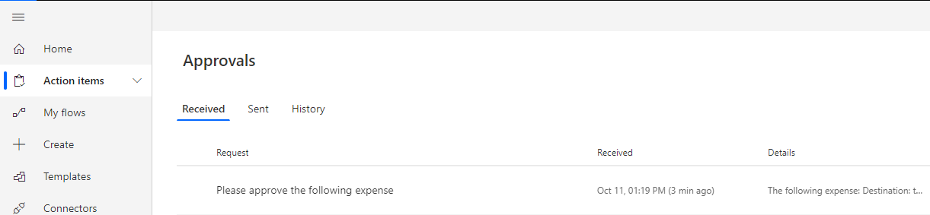

* + 1. On the **Received** tab, click the item to be approved/rejected to display an information pane.

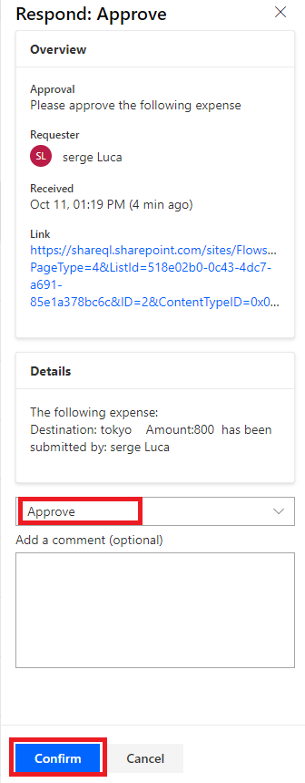

* + 1. Select **Approve**, and then click **Confirm**.

The Flow will send a you notification by e-mail :

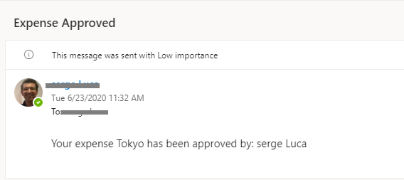

#### Task 2.3: Extending the flow by adding a new status when the flow is waiting

1. Click **Edit** on your flow’s details page.
2. Add a SharePoint **Update item** action between the trigger and the condition, and complete as shown in the following screenshot.

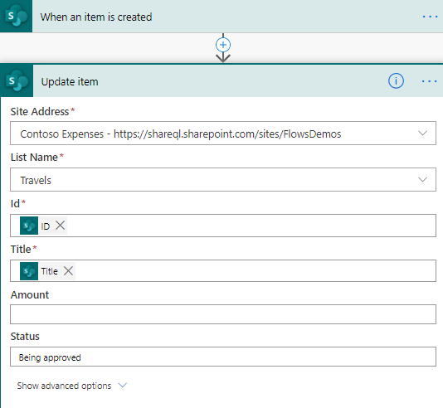

**Hint**:

* The **ID** Dynamic value comes from the trigger and identifies the corresponding SharePoint list item.
* **Title** also comes from the trigger,
* Type the value **Being approved** in the **Status** field:

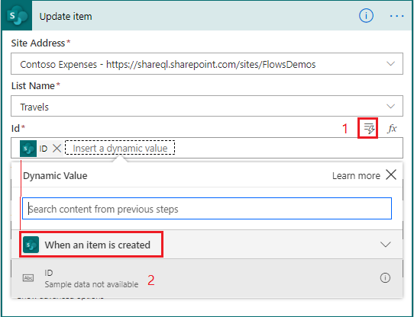

1. Apply the same logic to display Approved or Rejected in the SharePoint list
2. Add a new travel expense item to the SharePoint list and check the value in its status column (it might take a few seconds before the flow starts):

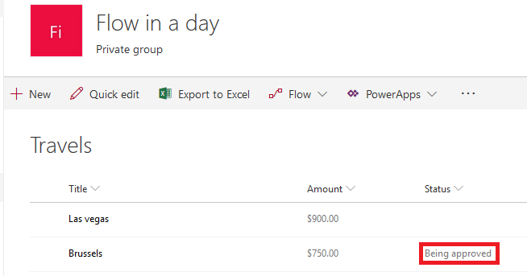

1. Approve and once the approval is completed, check the status value in the list,.

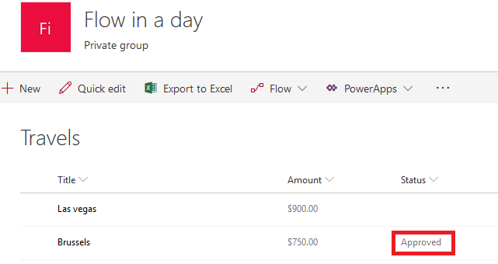

**Optional exercise if time permits**:

Amend the flow to automatically approve the expense If the amount is smaller than $500, otherwise, the expense item will progress through approved process.

**We need your feedback**

Do you want to report an issue or to suggest something? We need your feedback: <https://github.com/Power-Automate-in-a-day/Training-by-the-community/issues>